**A REMOTE SUMMER INTERNSHIP PROGRAM**

**PROJECT REPORT**

**ON**

**Smart Agriculture system based on IoT**

**2020**

**Submitted By:**

**Himanshu Jain**

**SBID:** **SB20200028227**

**Acknowledgement**

I, Himanshu Jain would like to convey my gratitude to TheSmartBridge Information Technology & Services to provide me an opportunity for 1 month Remote Summer Internship Program and giving me the platform to interact with industry professionals and to learn new concepts and to deploy it.

I would also like to thank Durgaprasad sir, to always help me to solve my queries and for giving me the opportunity to work on this project.

I extend my warm gratitude and regards to everyone who helped me during my internship.

**Himanshu Jain**

**SBID:** **SB20200028227**

**Table of Contents**

|  |  |  |
| --- | --- | --- |
| **S.NO.** | **TOPICS** |  |
|  | Introduction |
|  | Literature Survey |
|  | Theoretical Analysis. |
|  | Flowchart |
|  | Result |
|  | Advantages and Disadvantages |
|  | Applications |
|  | Conclusion |
|  | Future Scope |
|  | Bibliography |
|  | Appendix |
|  |  | |

**CHAPTER 1**

**INTRODUCTION**

* 1. **Overview**

Plants had and still have a key role in the history of life on earth. They are responsible for presence of oxygen needed for baron survival on this planet. At the same time agriculture is also important to human beings because they forms the basis for food security. Agriculture plays a vital role in India's economy. It is very important that farmer who are responsible for agriculture should have better control over his field.

The objectives of this report is to proposed IoT based Smart Agricultue System which will

enable farmers to have live data of soil moisture, humidity and temperature. Apart from this he will also able to have an eye on climatic data such as pressure, temperature and humidity of their region. This system help farmer to have control over his motor. He will be able to control motor remotely even if he is far away from his field.

* 1. **Purpose**

The purpose of this project is to make a farmer enable his control over control unit of water motor and he will be able to switch it OFF or ON on the basis of needs of his crops. By judging on the basis of his crops factor also climatic condition, he can supply water to his crops.

**CHAPTER 2**

**LITERATURE SURVEY**

* 1. **Existing problem**

In the present scenario, we can observe that farmer have to face lot of struggle in farming. He has to make everything good, so that the yield will be good. He also has to stay near to his field. He has to make sure that watering of crop should be done properly, soil moisture and humidity should be perfect. Due to this farmer has to face a lot of problems.

* 1. **Proposed solution**

The only solution to his problem is automation of control unit of water motor. If farmer was able to control how much amount of water should be used for agriculture on the basis of soil moisture, temperature and humidity remotely then he can also utilize his time in other activity. Our solution to this problem is that to provide an application which is user interactive which retrieves data from the field through the IoT sensor and also changes is hardware of water motor, so that on a button click he will be able to make motor either ON or OFF. Also he can supply sufficient amount of water on the basis of live weather condition.

**CHAPTER 3**

**THEORETICAL ANALYSIS**

* 1. **Block diagram**

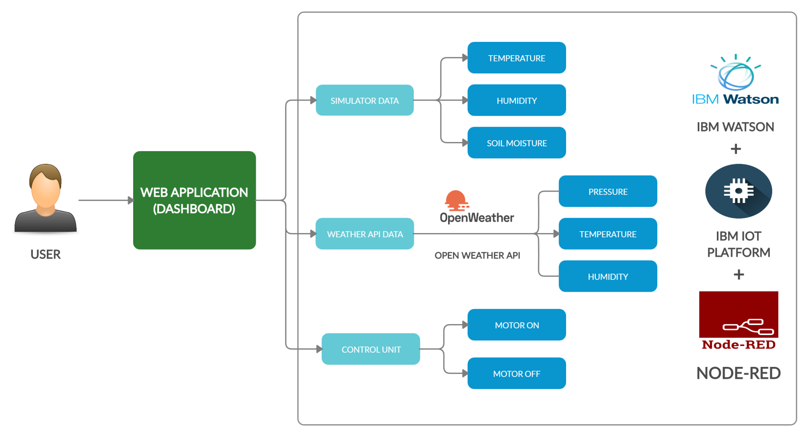

**3.2 Hardware / Software designing**

Smart agriculture system implements on simulator, so there is no use of hardware designing and software designing includes

* Creation of web application through node red
* Creation of device on IBM IoT platform available on IBM cloud
* Use of IBM simulator instead of data from hardware.
* Retrieving data from open weather API to get details about climatic condition of a region
* Use of node red dashboard nodes to create interactive control unit.
* Use of python language to make control on motor.

In this project, web application is created by node red which also collapse with device created on IBM IoT platform through API and other authentication. IBM simulator is used to change data of IoT device instead of using any hardware sensor. Python language is used to depicts the control over motor. Node-red’s node also used to take data from open weather API.

**CHAPTER 4**

**FLOWCHART**

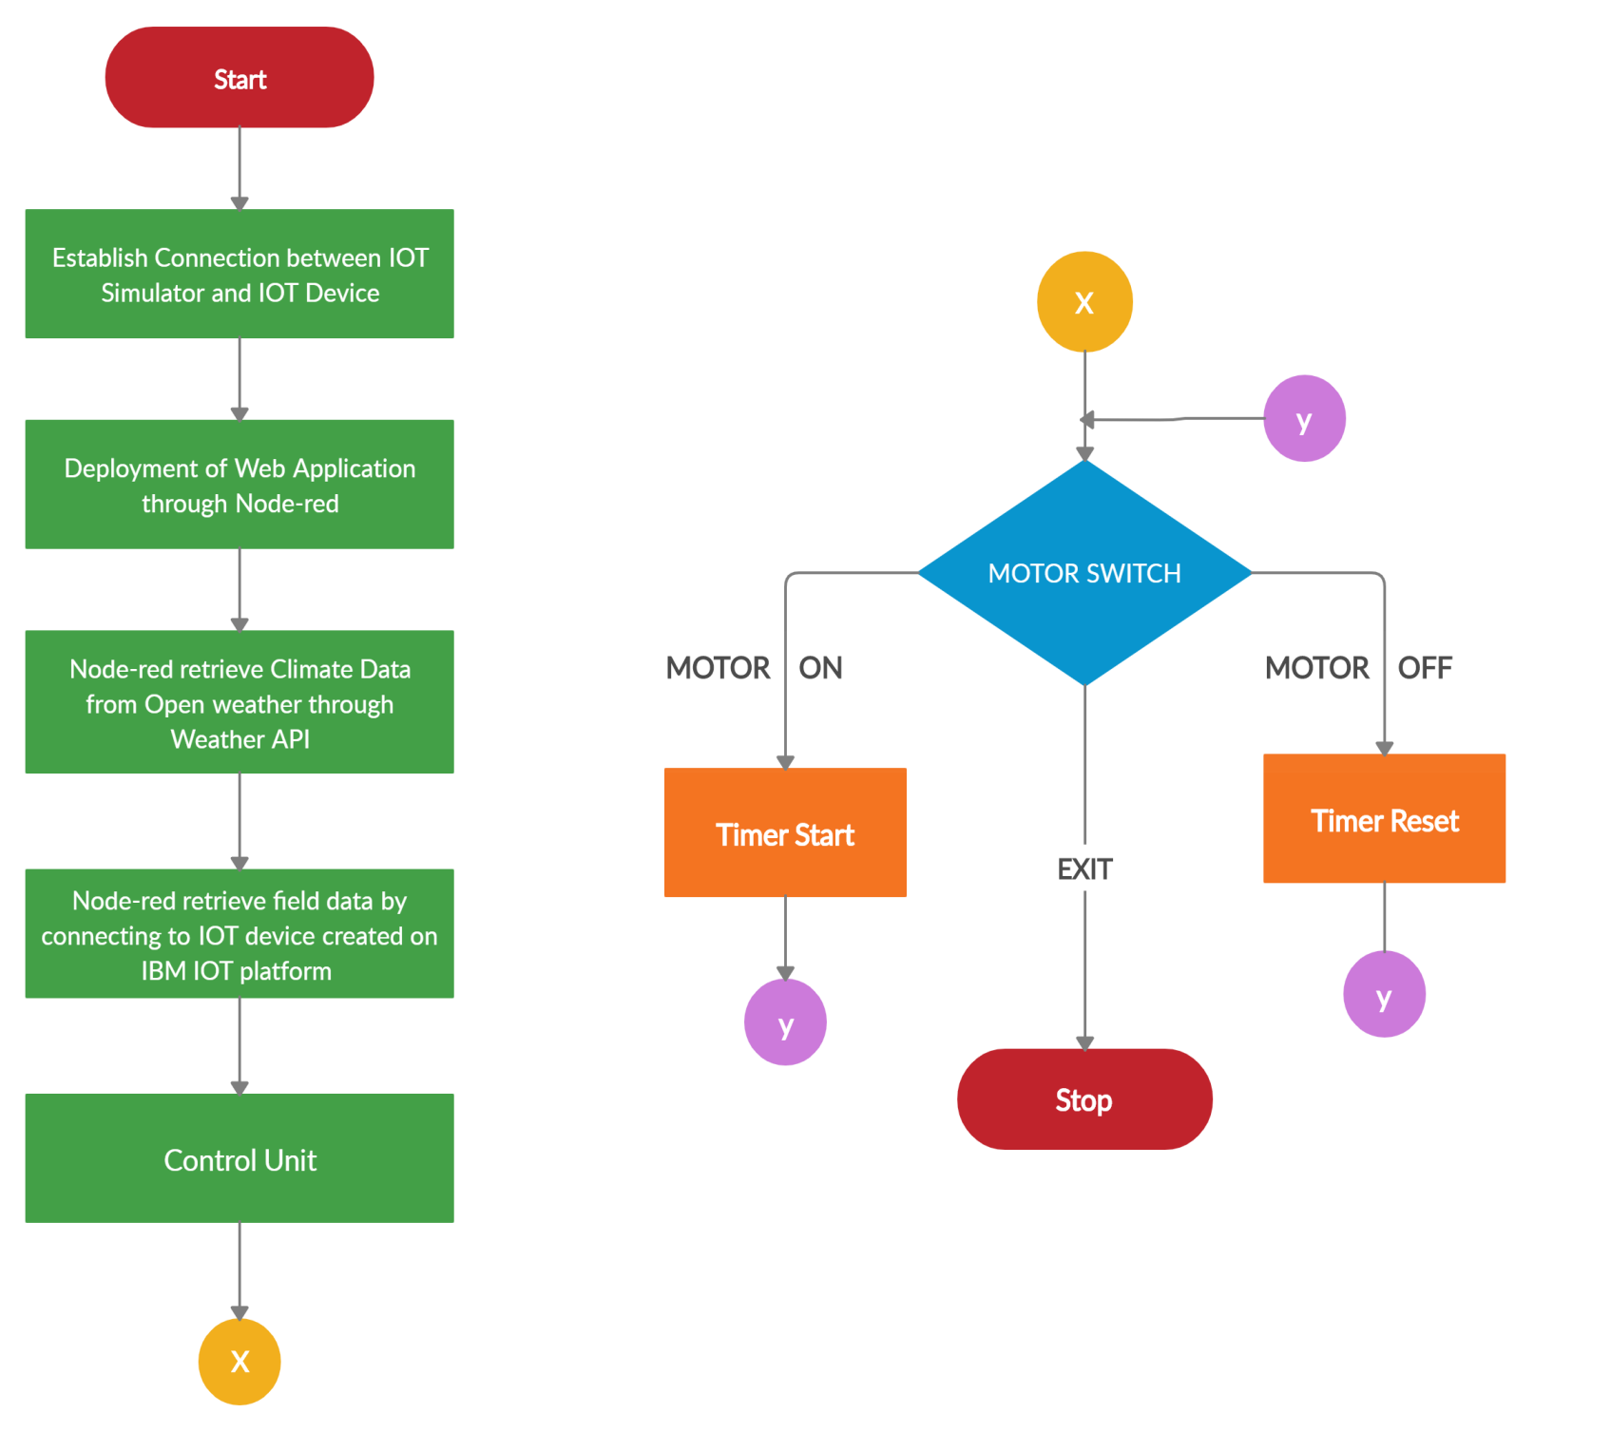

**CHAPTER 5**

**RESULT**

The Smart Agriculture make ease to farmer through which he can easily & effectively can do land cultivation .The farmer can control the flow of water through the web application. Through the web application, the farmer got the remote connectivity to his water supply motor.

The connectivity of farmer becomes easy with this IoT application. The IOT application helps to justify the weather of that area so farmer can do water supply effectively.

**CHAPTER 6**

**ADVANTAGES & DISADVANTAGES**

* **Advantages  
  ➨**It allows farmers to maximize yields using minimum resources such as water, etc.

**➨**Water Conservation

**➨**It is cost effective method.  
➨It delivers high quality crop production**.**

* **Disadvantages**

Following are the drawbacks of Smart Agriculture System:  
➨The smart agriculture needs availability of internet continuously. Rural part of most of the developing countries does not fulfill this requirement. Moreover internet connection is slower.  
➨The smart farming based equipments require farmers to understand and learn the use of technology. This is major challange in adopting smart agriculture farming at large scale across the countries.

**CHAPTER 7**

**APPLICATIONS**

**1** **Precision Farming**

The adoption of access to high-speed internet, mobile devices, and reliable, low-cost satellites (for imagery and positioning) by the manufacturer are a few key technologies characterizing the precision agriculture trend. By adopting this system, it helps in reduction of cost and yield will also increase.

**2.** L**ive Monitoring**

This system can be implemented in any small scale, medium scale or large scale agriculture. Through this live monitoring of field can be done which will be useful to increase the growth. By monitoring different parameter accurately, there will be proper supply of water, pesticides, fertilizers etc.

**CHAPTER 8**

**CONCLUSION**

IoT based SMART Agriculture SYSTEM for live Monitoring of Temperature, Humidity and Soil Moisture has been proposed using IBM Simulator and Cloud Computing . The System has high efficiency and accuracy in fetching the live data of temperature, humidity and soil moisture not only from field but also collecting weather data. The IoT based smart agriculture System being proposed via this report will assist farmers in increasing the agriculture yield and take efficient care of food production as the System will always provide helping hand to farmers for getting accurate live feed of environmental temperature and soil moisture with more than 99% accurate results.

**CHAPTER 9**

**FUTURE SCOPE**

Future work would be focused more on increasing sensors on this system to fetch more data especially with regard to Pest Control and by also integrating GPS module in this system to enhance this Agriculture IoT Technology to full-fledged Agriculture Precision ready product. This project is now implemented through web application but it also find it utilities in mobile application. Apart from controlling water supply motor, we can also enhance it with other functionalities such as pH determination of soil, plant growth etc.

**CHAPTER 10**

**BIBLIOGRAPHY**

Following resources are helpful in creation of this project:

1. <https://dzone.com/articles/iot-application-development-tips-to-make-it-succes>
2. <https://cloud.ibm.com/docs>
3. <https://nodered.org/>
4. <https://internetofthings.ibmcloud.com/>
5. <https://cloud.ibm.com/docs/services/IoT?topic=iot-platform-ref-index>
6. <https://nodered.org/docs/getting-started/windows#3-run-node-red>